Style File for LEES 2016 abstract
Setsuko Tajima^{1,2}, Shin-ichi Kimura^{1,2,3}, and Hidekazu Okamura^{1,4}
¹Organizing Committee of LEES 2016 Conference, Biwako, Japan
²Department of Physics, Osaka University, Toyonaka 560-0043, Japan
³Graduate School of Frontier Biosciences, Osaka University, Suita 565-0871, Japan
⁴Faculty of Engineering, Tokushima University, Tokushima 770-8506, Japan

This is the style file for the format of LEES 2016 abstracts. Fonts of Times, Times New Roman and Symbol are applicable to your reports, including figure legends and blank spaces. The font sizes and styles for your reports are listed in Table 1. In addition, the examples for references are indicated in the end of this draft.
At the beginning of each paragraph, two space characters should be inserted as an indent.
Regarding the Figure, "Figure #" and "Fig. #" should be used at the beginning of sentence and in the sentence, respectively.

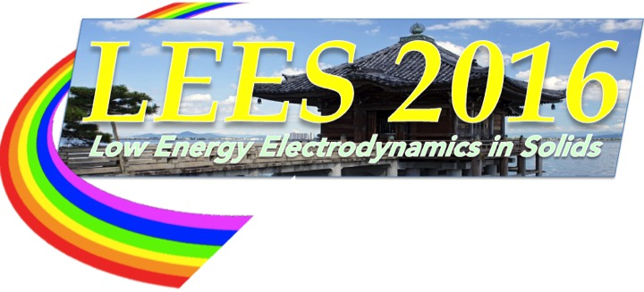

Fig. 1. Logo of the LEES 2016 conference.

Table 1. Font size and style.
 | Font Size | Style
Title | 14 pt | Bold | Ref: Text | 11 pt | Normal
Author Name | 12 pt | Normal | Ref: et al. | 11 pt | Italic
Affiliation | 11 pt | Italic | Ref: Volume | 11 pt | Bold
Text | 11 pt | Normal | Caption | 11 pt | Normal

[1] A. Name, B. Name, and C. Name, Phys. Rev. Lett. 123, 456789 (2016).
[2] A. Name et al., Nature 123, 456789 (2016).
[3] A. Name, Textbook (MM Press, Osaka, 2015).

